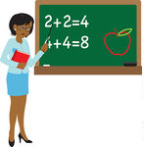

Ms. Jackson’s Procedures Manual

A Guide to the Routines and Procedures of Our Classroom

Classroom Jobs
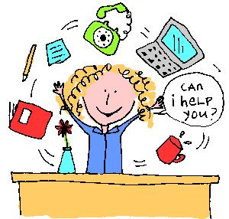
Teacher Assistant

Line Leader

Sanitation Helper
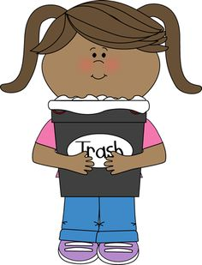

Snack Helper

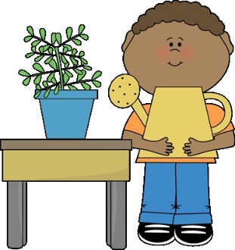
Plant and Pet Helper
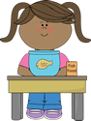

Table Captains

Librarian
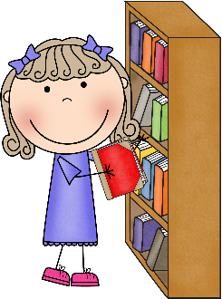

Electrician
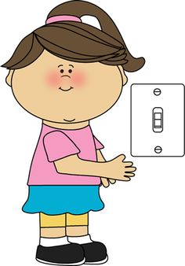

Beginning the Day

Morning Greeting

Before I walk into the classroom, I will:
- Say “Good Morning” to my teacher.
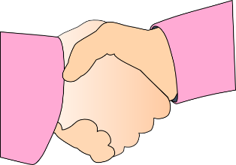
- Greet her with a handshake, high five, or a hug.
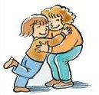

Consequence: If I don’t greet my teacher in the morning, I will not be able to come inside until I do.

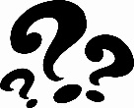
Why?: When my teacher greets me, this lets me know she cares about me and wants me to have an awesome day.
Morning Jobs
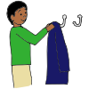
We start the day as C.H.A.M.P.S. every morning:
C- Coats and backpacks hung up
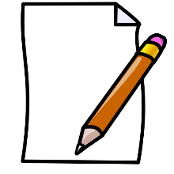
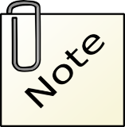
H- Homework turned in

A - All notes on the teacher’s desk
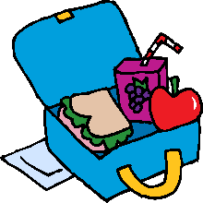
M - Make lunch choice

P - Pencils sharpened (2)
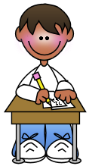
S- Start morning work

Consequence: If I do not do my morning work, I will have to go back and complete my jobs over again. This may mean I won’t have time for my work and may have to do it during my free time. I also may lose my turn to have classroom job.

Why?: If I don’t complete my morning jobs, someone may trip over my things because they are not hung up or the cafeteria may not have enough lunch for me.
Family Meeting
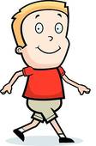
When my teacher calls for a family meeting, I will:
- Walk quietly to the rug.
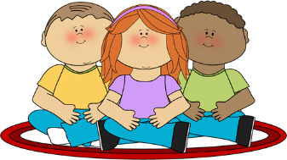
- Have a seat in my spot.

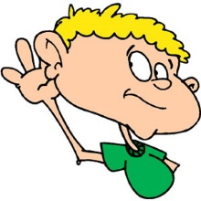
- Listen while my teacher and friends are talking.

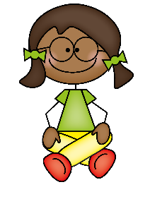
- Wait for my turn to talk.

Consequence: If I don’t participate in family meetings, I may lose my opportunity to talk and I may not be prepared for the day.

Why?: Family meetings give me a chance to share anything I want with my teacher.

Folders
When I am finished unpacking my folder, I will:
- Make sure my folder is empty.

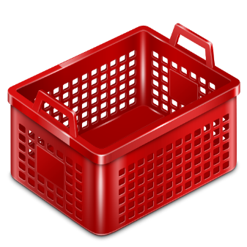
- Place in it the bin.

Consequence: If my folder is not empty in the bin, I may not get important announcements.

Why?: My teacher needs to send important information home and my folder should be empty so it will have a place to go and in the bin so she’ll know where to find it.

Where to Put Snacks

If I have a snack from home, I will:
- Take it out of my backpack in the morning.

- Ask my teacher to write my name on it.

- Place it in the snack basket.

Consequence: If I don’t get my snack out in the morning, I will not be able to eat it during snack time.

Why?: If I have to go to my backpack and get my snack out, I may run out of time to eat my snack.

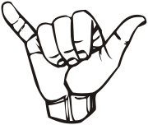

Management Ideas
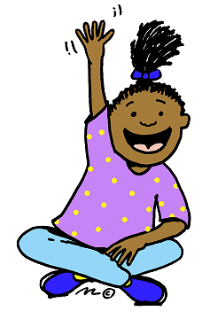

Attention Getters (“Gimme 5”)

When my teacher says “Gimme 5”, I will:
- Stop what I am doing.
- Look at my teacher. (2 eyes)
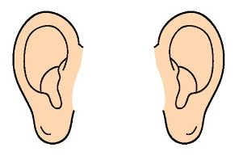

- Listen to my teacher. (2 ears)
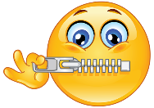
- Lock my lips. (1 mouth)

Consequence: If I don’t follow the procedure, my teacher may think I can’t hear her and walk over to me to repeat it. I also may stop my class from moving on to the next thing.

Why?: When I follow the procedure, I know what my teacher wants me to do next.
Attention Getters (“Macaroni and Cheese!”)

When my teacher says “Macaroni and Cheese!”, I will:
- Say “Everybody freeze!” back to her.
- Stop what I am doing.
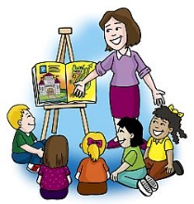
- Turn and face my teacher.

Consequence: If I don’t follow the procedure, my teacher may think I can’t hear her and walk over to me to repeat it. I also may stop my class from moving on to the next thing.

Why?: When I follow the procedure, I know what my teacher wants me to do next.
“Me too” Signal
When my teacher or my friends say something that I agree with, instead of talking, I will:
- Hold out my pinky finger and thumb.

- Twist my hand back and forth.

This lets my teacher silently know I agree!

Consequence: If I do not use the “me too” signal, my teacher may not think I agree with her or my friends.

Why?: When everybody is shouting “me too”, my teacher cannot tell who is talking. When I use my signal, my teacher can tell right away that I agree.
Getting the Teacher’s Attention

When I want to ask a question, say something, or need my teacher’s attention, I will:
- Quietly raise my hand.
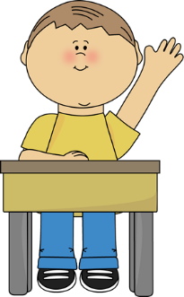
- Wait for my teacher to see my hand.

If my teacher is talking to someone else or helping another student, I know I will have to wait.

Consequence: If I don’t raise my hand, my teacher will not notice me.

Why?: If my teacher is working with another student, I will not be able to have her attention, but if I raise my hand that lets her know I need her attention when she’s finished.

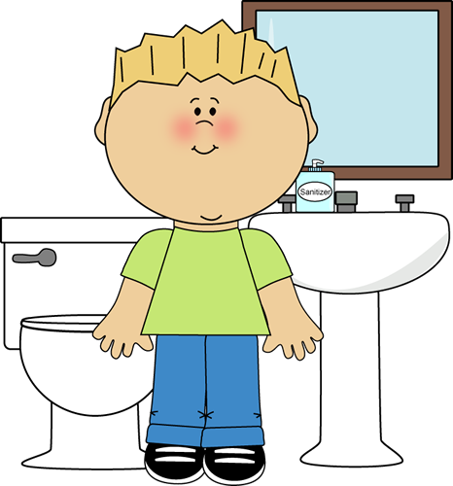

Daily Needs

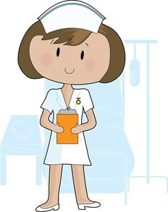
Using the restroom

If I need to use the restroom, I will:
- Raise my hand and use the bathroom signal.

- Wait for the yes or no signal from my teacher.

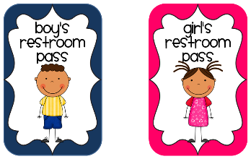
- YES: Move my card on the “Gone for A while” chart. NO: Go back to my work.

Consequence: If I do not follow the procedure for using the restroom, I may not be able to use the restroom by myself again.

Why?: When I put my bathroom card into my pocket, my teacher will know where I am in case of an emergency. When I use my bathroom signal, I won’t interrupt my teacher when she is teaching or working with other students.
Getting Water

When I need a drink of water, I will:
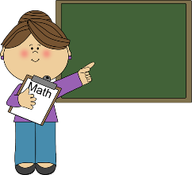
- Make sure a teacher is not talking.

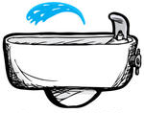
- Look to see if no one is at the fountain.

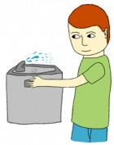
- If no one is there, I may get a drink of water.

Consequence: If I don’t follow the procedure, I will have to ask every time before I can get water. My teacher may also think I am not independent.

Why?: If there is already someone at the water fountain, I do not want to waste time waiting behind them. I also need to listen when my teacher is talking so I will know what to do.
Going to the Nurse
If I start to feel sick and need to go to the nurse, I will:
- Raise my hand quietly.
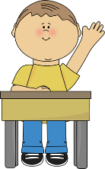
- Wait for my teacher to see my hand.
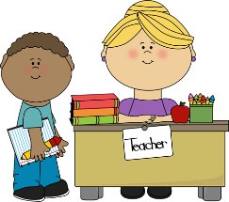
- Tell my teacher what is wrong.

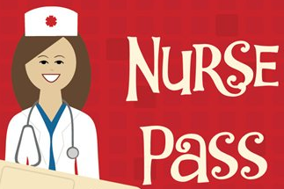
- If she says yes, put the nurse pass in the “Gone for a while” chart.

Consequence: If I don’t follow the procedure, my teacher may have to send someone to the nurse with me instead of me being independent and going by myself.

Why?: If I don’t put the nurse pass in my number pocket, my teacher may not know where I am in case of an emergency.

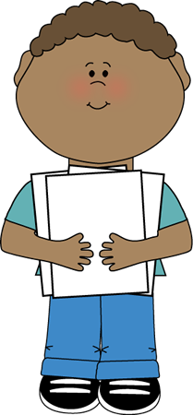

Paperwork
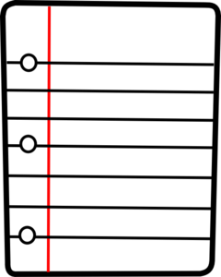

When You Complete Your Work

When I am done with my work, I will:
- Check to see if everything is done.

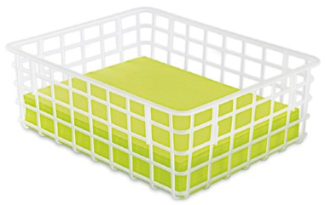
- Place my work in the morning work basket or my family basket.

- MORNING: Pick an activity from the “I’m Done” jar or read a book. CENTERS: Pick an activity from the shelves.

Consequence: If don’t pick an activity to do after I finish my work, my teacher may think I do not know what to do and remind me. She may think I cannot be independent.

Why?: When I pick an activity after I finish my assignment, it shows my teacher that I am not wasting learning time.
Returning Corrected Paperwork

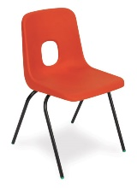
When my teacher hands my paper back to me, I will:
- Go to my seat.
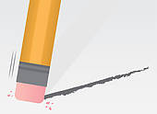
- Fix my mistakes.
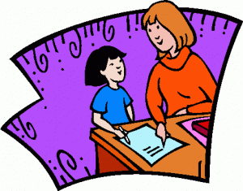
- Let my teacher see it.

- Put it in my cubby to go home.

Consequences: My teacher will take it out and give it back to me again to correct if I don’t correct my work.

Why?: When I correct my mistakes, it helps my teacher know if I understand something or not.
Unfinished Work

If I am not done with my work, I will:
- Draw a dot on the top of my paper.

- Put it in the “Unfinished” folder.

Consequence: My teacher will think I did not do it and I will have to start all over again.

Why?: It will help me to be organized and keep up with the work that still needs to be finished.

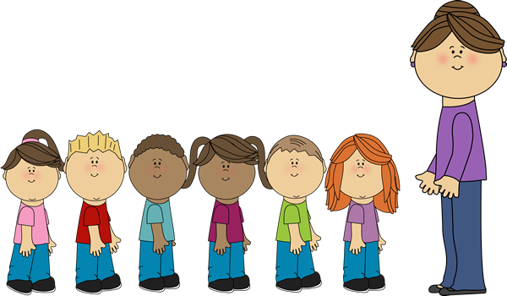

Outside the Classroom

How to Line Up

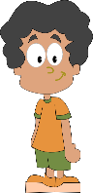
When it’s my turn to line up, I will:
- Stand up.

- Push in my chair quietly.
- Walk to the line.
- Face the front of the line.
- Lock my lips.

Consequence: If I don’t line up the correct way, I will have to do it again. This means I may cause my friends to be late to wherever we are going.

Why?: I have to line up the correct way so my teacher knows I am ready to walk in the halls.

How to Walk in the Hall

When I am in the hall, I will:
- Lock my lips.
- Walk with my feather feet.

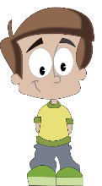
- Keep my hands by my side or behind my back.

- Walk in a line behind my friends.

Consequences: If I don’t walk in the hall the correct way, I will have to go back and do it again. This means I may cause my friends to be late to where we are going.

Why?: When I am in the halls, I need to be quiet to respect the other classrooms and their learning time.
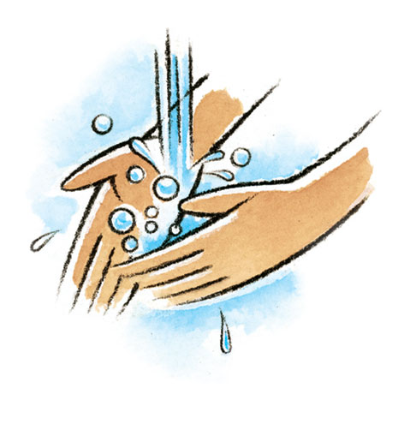

Odds and Ends
When the Intercom Comes On

When the intercom comes on, I will:
- STOP what I am doing IMMEDIATELY!
- Lock my lips.

Consequence: If I am not quiet when the intercom comes on, I will have to practice being quiet during another time when my friends are allowed to talk.

Why?: If I am talking when the intercom is on, my teacher may miss an important announcement.

How to Wash Hands at the Sink

When I wash my hands at the sink, I will…
- Turn the water on and wet my hands.
- Get one pump of soap.
- Scrub my hands while singing the “Washing Hands” Song.
- Rinse my hands with water.
- Dry my hands and turn the water off with paper towel.
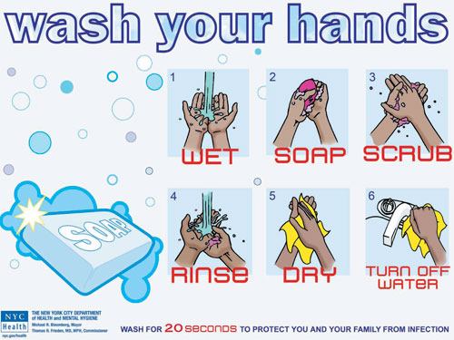

Consequence: If I am unable to follow the procedure, my teacher may have to pump my soap for me. She also may think I am independent.

Why?: The sink is for washing my hands, not playing. I need to wash my hands so I can be germ-free!
How to Use Hand Sanitizer

When I need hand sanitizer, I will:
- Get one pump of sanitizer.

- Shake my hands until they are dry.

Consequence: If I do not use the sanitizer the correct way, I will not be allowed to use it anymore.

Why?: I need to use hand sanitizer to kill the germs that are on my hands.

Entering the Classroom
Whenever I come into the classroom, I will:
- Lock my lips BEFORE coming in.
- Walk into the classroom.

- Morning: Complete my morning jobs.

- After specials, lunch or recess: Go quietly to my seat.

Consequence: If I do not enter the classroom correctly, I will have to go back and do it again. My teacher also may have to walk in with and to my seat. That means I am not being independent.

Why?: When I enter the classroom quietly, it shows my teacher I am ready to learn and she may pick me to do special assignments.
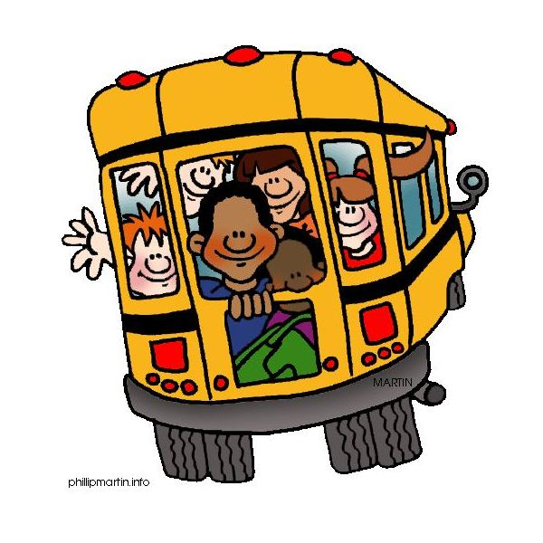

Ending the Day

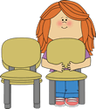
Packing Up
When my teacher calls me to pack up, I will:
- Get my backpack and coat.

- Get my folder from my cubby and put any papers in my folder.
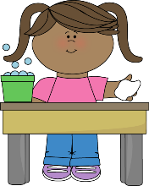
- Clean my table and the floor.

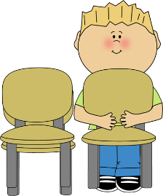
- Take my chair bag off and stack my chair.

Consequence: If I don’t follow the procedure for packing up, I will have to start over.

Why?: I need to pack up so I can take my things with me and go home!

