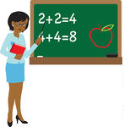

Ms. Jackson’s Procedures Manual

A Guide to the Routines and Procedures of Our Classroom
Introduction
Procedures are a part of life. We follow procedures for almost everything we do. The reason we have procedures in life is so that people can function in society knowing the acceptable and efficient ways other people do things.

There are procedures in this classroom. These procedures establish our classroom culture.

This is the teacher version of the procedures manual. The teacher version provides a more in depth version of the procedure, consequence, and rationale. The italicized writing is the extension and is only located in the teacher version.

This procedures manual is intended for teacher use, parent use, substitute use, etc.

This procedures manual is subject to change.

All consequences are based on natural and logical thinking. If procedures are continually unfollowed, the student may have to complete a “think sheet” and have a conversation with the teacher.

Classroom Jobs

Teacher Assistant
The teacher assistant is a big responsibility. The teacher assistant is responsible for running errands, providing the lunch count, and other general needs made by the teacher. Because of this the teacher assistant is a student that shows an exemplary responsibility level.
This position changes bi-weekly. This is so students have an opportunity to really develop leadership and responsibility skills.
Line Leader
The responsibility of the line leader is to start the line and be the example of how to walk in a line.
This position changes weekly.
Sanitation Helper
The sanitation helper is responsible for emptying all the trash cans and setting them outside the classroom at the end of the day.
This position changes weekly.

Snack Helper
The snack helper will be responsible for passing at out snack during snack time.
This position changes weekly.
Plant and Pet Helper
The plant and pet helper will be responsible for watering the plants and feeding the class pets.
This position changes weekly.
Table Captains
The table captains will be responsible for passing out papers and making sure their table stays on task.
This position changes weekly.
Librarian
The librarian is responsible for keeping the reading center neat.
This position changes weekly.
Electrician
This electrician is responsible for turning off and on the lights.
This position changes weekly
*Classroom Helpers are subject to change even in the middle of a term. Classroom helpers must be responsible and trustworthy. The teacher reserves the right to change them as seen fit.*
Procedures List

Beginning the Day
- Morning Greeting
- Morning Jobs
- Family Meeting
- Folders
- Where to Put Snacks
Management Ideas
- Attention Getters (“Gimme 5”)
- Attention Getters (“Macaroni and Cheese!”)
- “Me too” Signal
- Getting the Teacher’s Attention
Daily Needs
- Using the Restroom
- Getting Water
- Going to the Nurse
Paperwork
- When You Complete Your Work
- Returning Corrected Work
- Unfinished Work
Outside the Classroom
- How to Line Up
- How to Walk in the Hall
Odds and Ends
- When the Intercom Comes On
- How to Wash Your Hands at the Sink
- How to Use Hand Sanitizer
- Entering the Classroom
Ending the Day
- Packing Up

Beginning the Day

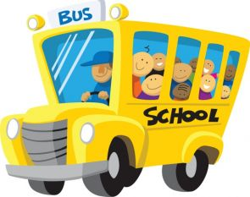
Morning Greeting
Before I walk into the classroom, I will:
- Say “Good Morning” to my teacher.
- Greet her with a handshake, high five, or a hug.

Consequence: If I don’t greet my teacher in the morning, I will not be able to come inside until I do. Students who do not greet the teacher will not be able to enter the classroom. This means they may get behind in their morning work.

Why/Rationale: When my teacher greets me, this lets me know she cares about me and wants me to have an awesome day. By greeting the students in the morning, the teacher is showcasing more than just academic concern for the student. Students also need to learn how to speak to someone when they enter the room as common courtesy.
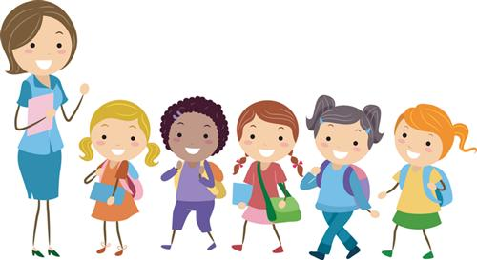
Morning Jobs
We enter the classroom as C.H.A.M.P.S. every morning:
C- Coats and backpacks hung up
H- Homework turned in
A - All notes on the teacher’s desk
M - Make lunch choice
P - Pencils sharpened (2)
S- Start morning work
The students will use this acronym to help remind them of what to do in the morning when they come in. Sometimes the students’ homework will be just to play game they take home. In this case they don’t have any homework to turn in, the students may need to turn in their nightly homework sign off sheet. Every student has a folder that they take home with a behavior sheet and information for the parents. The students will need to look in their folders and take out any notes for the teacher. The students also will need to make their lunch choice by moving their names to their lunch choice for the day. Once the students have unpacked their backpacks and made their lunch choice, they will need to make sure they have 2 sharpened pencils. (The students will not use the pencil sharpener. Instead they will grab 2 sharpened ones from the container.) Finally, the students will start their morning work for the day.
Consequence: If I do not do my morning work, I will have to go back and complete my jobs over again. This may mean I won’t have time for my work and may have to do it during my free time. I also may lose my turn to have classroom job. Students who do not complete their morning jobs will be told to go back and complete them again. If the student has to use more time than intended to complete the morning jobs, he/she may not have enough time to finish the morning work and will have to complete it during free time. They may lose their right to complete classroom jobs.
Why/ Rationale: If I don’t complete my morning jobs, someone may trip over my things because they are not hung up or the cafeteria may not have enough lunch for me. If students do not take care of morning jobs, someone may get hurt tripping over their things, the teacher will have no way of knowing if the students did his/her homework, the teacher may not receive an urgent note from a parent, or the student’s lunch choice may not get put in.
Family Meeting
When my teacher calls for a family meeting, I will:
- Walk quietly to the rug.
- Have a seat in my spot.
- Listen while my teacher and friends are talking.
- Wait for my turn to talk.

Consequence: If I don’t participate in family meetings, I may lose my opportunity to talk and I may not be prepared for the day. Students who are not participating on the rug may lose their opportunity to share their thoughts and may not hear what the activities for the day are.

Why/Rationale: Family meetings give me a chance to share anything I want with my teacher. Family meetings give students an opportunity to share with the teacher about their night or weekend or whatever. It also gives the teacher the chance to prepare the students for their day so every student will know what is going on and what is expected of them.
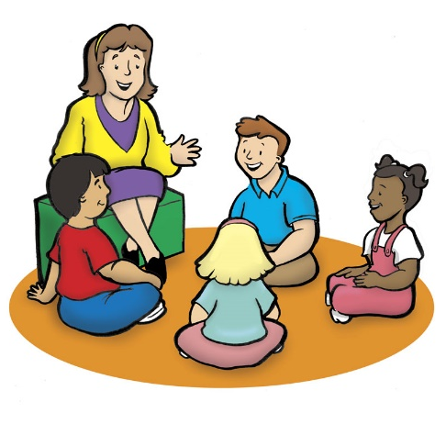
Folders
When I am finished unpacking my folder, I will:
- Make sure my folder is empty.
- Place in it the bin.

Consequence: If my folder is not empty in the bin, I may not get important announcements. The teacher will take the folder and place important paperwork in them and then put them in the cubbies for the students to take home. If the student does not place his/her folder in the bin, their parents may miss important information from their teacher.

Why/Rationale: My teacher needs to send important information home and my folder should be empty so it will have a place to go and in the bin so she’ll know where to find it.
Where to Put Snacks
If I have a snack from home, I will:
- Take it out of my backpack in the morning.
- Ask my teacher to write my name on it.
- Place it in the snack basket.
Snack will be provided by the teacher, but students are more than welcome to bring in their own.

Consequence: If I don’t get my snack out in the morning, I will not be able to eat it during snack time. If a student does not put his/her snack in the basket in the morning, he/she will not be allowed to go and get it during snack time.

Why/Rationale: If I have to go to my backpack and get my snack out, I may run out of time to eat my snack. Students are not allowed to go to their backpacks because snack time is limited and they are wasting time if they have to go to their backpacks to retrieve their snack. Also, if more than one student had to get their snack out, it could potentially get chaotic in the backpack area.

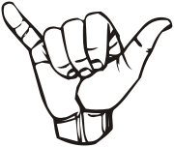

Management Ideas
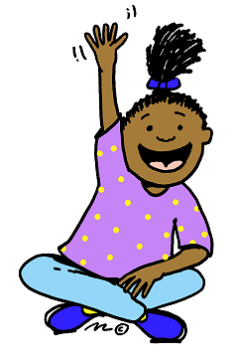

Attention Getters (Gimme 5)
When my teacher says “Gimme 5”, I will:
- Stop what I am doing.
- Look at my teacher. (2 eyes)
- Listen to my teacher. (2 ears)
- Lock my lips. (1 mouth)
When the teacher says “Gimme 5”, the students will them their undivided attention. The student should have both eyes on the teacher, both ears listening to the teacher, 1 mouth closed, and should stop whatever they are doing.

Consequence: If I don’t follow the procedure, my teacher may think I can’t hear her and walk over to me to repeat it. I also may stop my class from moving on to the next thing. If a student does not complete the procedure, the teacher may think the student does not hear her and walk over to the student to repeat the phrase. The student may also hold the class up from moving to the next assignment.

Why/ Rationale: When I follow the procedure, I know what my teacher wants me to do next. The teacher will need to get the attention of the students multiple times during the day so it is very important the students are able to follow this procedure.

Attention Getters (“Macaroni and Cheese!”)
When my teacher says “Macaroni and Cheese!”, I will:
- Say “Everybody freeze!” back to her.
- Stop what I am doing.
- Turn and face my teacher.
Students should stop what they are doing and turn and face their teacher quietly right away.

Consequence: If I don’t follow the procedure, my teacher may think I can’t hear her and walk over to me to repeat it. I also may stop my class from moving on to the next thing. If a student does not complete the procedure, the teacher may think the student does not hear her and walk over to the student to repeat the phrase. The student may also hold the class up from moving to the next assignment.

Why/Rationale: When I follow the procedure, I know what my teacher wants me to do next. The teacher will need to get the attention of the students multiple times during the day so it is very important the students are able to follow this procedure.

“Me too” Signal
When my teacher or my friends say something that I agree with, instead of talking, I will:
- Hold out my pinky finger and thumb.
- Twist my hand back and forth.
This lets my teacher silently know I agree!
Instead of students shouting out “me too”, the silent signal lets the teacher know that the student agrees.

Consequence: If I do not use the “me too” signal, my teacher may not think I agree with her or my friends. The teacher will not respond to the student shouting “me too”. If a student gives answer and another student shouts “me too”, the teacher may ask the student for his answer, ignoring the fact that he/she shouted out me too.

Why/Rationale: When everybody is shouting “me too”, my teacher cannot tell who is talking. When I use my signal, my teacher can tell right away that I agree. Having students shout out can be distracting especially to students who are still thinking and need a little more time. Using the signal is a quiet way the students can relay to the teacher they agree with what is being said.
Getting the Teacher’s Attention
When I want to ask a question, say something, or need my teacher’s attention, I will:
- Quietly raise my hand.
- Wait for my teacher to see my hand.
If my teacher is talking to someone else or helping another student, I know I will have to wait.

Consequence: If I don’t raise my hand, my teacher will not notice me. The teacher will simply ignore the student shouting out and will reinforce or restate the procedure.

Why/Rationale: If my teacher is working with another student, I will not be able to have her attention, but if I raise my hand that lets her know I need her attention when she’s finished. It’s important that students know how to properly ask for attention. Raising their hand to ask a question or say something is going to be something they use all throughout their school years.

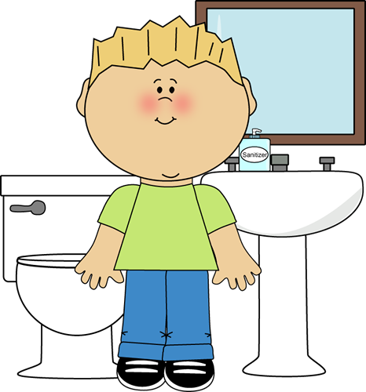

Daily Needs

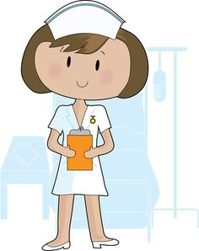
Using the restroom
If I need to use the restroom, I will:
- Raise my hand and use the bathroom signal. (sign language for bathroom)
- Wait for the yes or no signal from my teacher. (yes and no in sign language)
- YES: Move my card on the “Gone for A while” chart. NO: Go back to my work.
In the classroom, there is a “Gone for A while” chart. This is chart is to help to the teacher and other students know where students are if they are outside of the classroom. When a student has to use the restroom, they will check the chart to see if 2 people are already in the restroom. If not, they will follow the steps for going to the restroom. If the answer is yes, the student will go to the chart and place one of the restroom passes in their number pocket. When they come back from the restroom, they will remove the pass from their pocket and place it back in its appropriate place.

Consequence: If I do not follow the procedure for using the restroom, I may not be able to use the restroom by myself again. Students who are unable to follow the procedure correctly will not be allowed to go to the restroom by themselves until they can learn to do the procedure correctly.

Why/Rationale: When I put my bathroom card into my pocket, my teacher will know where I am in case of an emergency. When I use my bathroom signal, I won’t interrupt my teacher when she is teaching or working with other students. Teachers are responsible for their students during the school day. In case of an emergency, the teacher needs to know where every students is at any given moment. It’s also important that the teacher can work with individuals or small groups without any minor disruptions such as asking to go to the restroom.
Getting Water
When I need a drink of water, I will:
- Make sure a teacher is not talking.
- Look to see if no one is at the fountain.
- If no one is there, I may get a drink of water.
There may not be more than one student at the sink at one time unless otherwise noted by the teacher. Students may also not get water if the teacher is teaching or giving directions.

Consequence: If I don’t follow the procedure, I will have to ask every time before I can get water. My teacher may also think I am not independent. Students who repeatedly do not follow the procedure will be required to ask permission before going to get water. Because of this the student may not be considered independent and may lose a chance of having a classroom job.

Why/Rationale: If there is already someone at the water fountain, I do not want to waste time waiting behind them. I also need to listen when my teacher is talking so I will know what to do. Students do not need to waste learning time by waiting in line at water fountain. Students also do not need to get water when a teacher is speaking.
Going to the Nurse
If I start to feel sick and need to go to the nurse, I will:
- Raise my hand quietly.
- Wait for my teacher to see my hand,
- Tell my teacher what is wrong.
- If she says yes, put the nurse pass in the “Gone for a while” chart.
If a student has vomited, he/she will automatically be taken to the nurse. If a student has to regularly go to the nurse for treatment, they may get up and put the pass in his/her number pocket and leave.

Consequence: If I don’t follow the procedure, my teacher may have to send someone to the nurse with me instead of me being independent and going by myself. If a student is unable to follow the procedure, the teacher may need to send someone with the student to nurse to make sure they get there and back.

Why/Rationale: If I don’t put the nurse pass in my number pocket, my teacher may not know where I am in case of an emergency. Teachers are responsible for their students during the school day. It is important the teacher knows where the students are at all times.

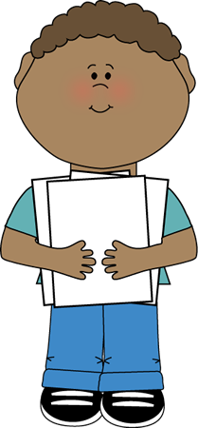

Paperwork
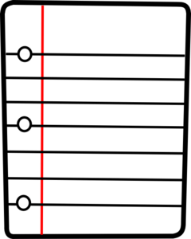

When You Complete Your Work
When I am done with my work, I will:
- Check to see if everything is done.
- Place my work in the morning work basket or my family basket.
- MORNING: Pick an activity from the “I’m Done” jar or read a book. CENTERS: Pick an activity from the shelves.
Once students are finished with their morning work, they will use the “I’m Done” jar to determine their next activity or read a book. Once the students are finished with math center work, they may grab a math center activity from the shelves. Once they are finished with literacy center work, they may pick a literacy center activity from the shelves. For students who are consistently finishing early, the teacher may have suggested activities for the students to complete to challenge them.

Consequence: If don’t pick an activity to do after I finish my work, my teacher may think I do not know what to do and remind me. She may think I cannot be independent. The teacher will remind the student of what he/she should be doing after they finish their work. If the behavior continues, the teacher may not think the student is ready to be independent and may not be able to have a class job.

Why/Rationale: When I pick an activity after I finish my assignment, it shows my teacher that I am not wasting learning time. The students should be independent enough to choose an assignment after finishing their work. If the teacher is working with a student or a group, the teacher needs to trust that the students know how to not waste learning time and pick an activity to continue working.
Returning Corrected Paperwork
When my teacher hands my paper back to me, I will:
- Go to my seat.
- Fix my mistakes.
- Let my teacher see it.
- Put it in my cubby to go home.
The teacher may tell the student to immediately put it in his/her cubby if no corrections need to be made.

Consequences: If I don’t correct my mistakes before putting it in my cubby, my teacher will take it out and give it back to me again to correct. She will also go over the procedure again. If a student does not follow the procedure, the teacher will think the student does not know the procedure and go over it again.

Why/Rationale: When I correct my mistakes, it helps my teacher know if I understand something or not. Correcting a mistake will let the teacher know if the student is having trouble with a concept or made a careless error.
Unfinished Work
If I am not done with my work, I will:
- Draw a dot on the top of my paper.
- Put it in the “Unfinished” folder.

Consequence: If I do not put my work in the “Unfinished” folder, my teacher will think I did not do it and I will have to start all over again. If the unfinished work cannot be found because it is not in the folder, the student will have to start the assignment over to complete it.

Why/Rationale: If I put my unfinished work in the folder, it will help me to be organized and keep up with the work that still needs to be finished. Having students put there unfinished work in a folder will allow them to know where the work that needs to be finished is. If the student has a place for finished work, he/she should also have a place for unfinished work.

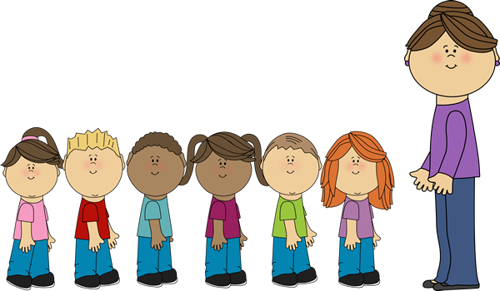

Outside the Classroom

How to Line Up
Each student is assigned a number. The numbers are based on alphabetical order. The students will line up in alphabetical order.
When it’s my turn to line up, I will:
- Stand up.
- Push in my chair quietly.
- Walk to the line.
- Get in line and face the front.
- Lock my lips.

Consequence: If I don’t line up the correct way, I will have to do it again. This means I may cause my friends to be late to wherever we are going. The student will return to his/her seat and start the procedure all over again.

Why/Rationale: I have to line up the correct way so my teacher knows I am ready to walk in the halls. Students have to walk in the halls quietly per school-wide rules. This ensures that as students are transitioning in the halls, they will not disturb the other classrooms and their learning time. Standing quietly in line BEFORE they enter the hallway prepares them for the appropriate hallway behavior (see hallway procedure). Students need to be in a straight line also per school-wide rules. Students will be safer if they are walking in a straight line as opposed to running down the hall and potentially bumping into one another. This also allows for space for adults and other classes to walk down the halls.

How to Walk in the Hall
When I am in the hall, I will:
- Lock my lips.
- Walk with my feather feet.
- Keep my hands by my side or behind my back.
- Walk in a line behind my friends.
Students will need to walk in the second square from the wall when in the hall per school rules.

Consequences: If I don’t walk in the hall the correct way, I will have to go back and do it again. This means I may cause my friends to be late to where we are going. For students who do not walk in the hall the correct way, the teacher will require them to go back to where they started to unfollow the procedure and have them try it again.

Why/Rationale: When I am in the halls, I need to be quiet to respect the other classrooms and their learning time. Transitions in the hallway need to be as quiet as possible so that other classrooms are not disturbed.
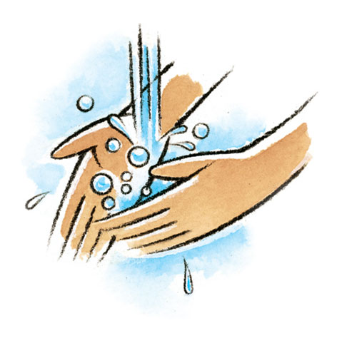

Odds and Ends
When the Intercom Comes On
When the intercom comes on, I will:
- STOP what I am doing IMMEDIATELY!
- Lock my lips.

Consequence: If I am not quiet when the intercom comes on, I will have to practice being quiet during another time when my friends are allowed to talk. Students who are not quiet when the intercom comes on will have to practice being quiet during a portion of lunch, recess, or free centers.

Why/Rationale: If I am talking when the intercom is on, my teacher may miss an important announcement. The office may buzz down to the room for a number of reasons. The teacher needs to be able to hear the message from the office, especially if it’s an emergency.

How to Wash Hands at the Sink
When I wash my hands at the sink, I will…
- Turn the water on and wet my hands.
- Get one pump of soap.
- Scrub my hands while singing the “Washing Hands” Song.
- Rinse my hands with water.
- Dry my hands and turn the water off with paper towel.

Consequence: If I am unable to follow the procedure for washing my hands, my teacher may have to pump my soap for me. She also may think I am independent. Students who are unable to wash their hands correctly without playing will have to have teacher supervision and this may result in them losing their status of independence meaning they will not be able to have a class job.

Why/Rationale: The sink is for washing my hands, not playing. I need to wash my hands so I can be germ-free! Washing your hands is a vital skill that most students learn way before they come to school. It is very important that students learn they need to wash their hands in order to keep from getting sick. They also need to learn the sink is not for playing in the water. There were be other activities where the students can play with water.
How to Use Hand Sanitizer
When I need hand sanitizer, I will:
- Get one pump of sanitizer.
- Shake my hands until they are dry.
Hand sanitizer should not be used in place of washing hands except when there is no water around.

Consequence: If I do not use the sanitizer the correct way, I will not be allowed to use it anymore. Students who do not use the hand sanitizer the correct way will not be able to use it again until the teacher says so.

Why/Rationale: I need to use hand sanitizer to kill the germs that are on my hands. Hand sanitizer can be used to clean hands when water is not available.
Entering the Classroom
Whenever I come into the classroom, I will:
- Lock my lips BEFORE coming in.
- Walk into the classroom.
- In the Morning: Complete my morning jobs.
- After specials, lunch or recess: Go quietly to my seat.
The students will need to enter the classroom quietly and walking. When the students walk in in the morning, they will need to start completing their morning jobs (see morning jobs). When the students enter the classroom after lunch, recess, or specials, the students will go directly to their seats unless otherwise stated by the teacher.

Consequence: If I do not enter the classroom correctly, I will have to go back and do it again. My teacher also may have to walk in with and to my seat. That means I am not being independent. Students who are unable to complete the procedure correctly will need to go back outside the classroom and do the procedure over again. If a student is having repeated trouble with the procedure, the teacher may need to escort the student into the classroom and to his/her seat to promote appropriate behavior.

Why/Rationale: When I enter the classroom quietly, it shows my teacher I am ready to learn and she may pick me to do special assignments. When a student enters the classroom quietly, this signifies that the student understands the classroom is a place for learning. Their job every day is to be a student. The student is showing the teacher that he/she is able to follow directions and can be trusted with special tasks, i.e. running errands.
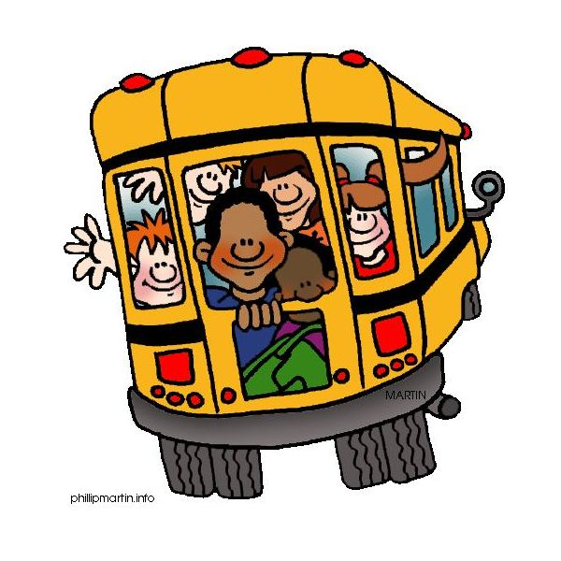

Ending the Day

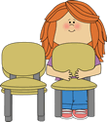
Packing Up
When my teacher calls me to pack up, I will:
- Get my backpack and coat.
- Get my folder from my cubby and put any papers in my folder.
- Clean my table and the floor.
- Take my chair bag off and stack my chair.

Consequence: If I don’t follow the procedure for packing up, I will have to start over. I also may leave something at school. If a student does not follow the procedure, they will be asked to try it again.

Why/Rationale: I need to pack up so I can take my things with me and go home! Students need to follow the procedure to make sure they don’t forget anything and that they will be ready for the next day.
