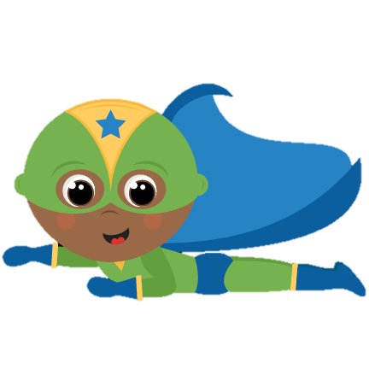

HOMEWORK

**Monday**

Read the passage Grouchy Girl. Use the text to answer the questions. Read the passage Tabby Plays. Use the text to answer the questions.

**Tuesday**

Look at the picture. Say the word. Then write the long a word. Read the words. Draw a picture of the long a word.

**Wednesday**

Read each word problem. Pick a strategy to solve (picture, number line, ten frame, etc). Write an equation to match the word problem. Write your answer and circle it.

**Thursday**

Cut out each of the statements. Decide if the statement is a fact or an opinion. Glue the statement in the correct column. *If you do not have scissors, write the number of the statement in the correct column.

**Bonus**: Play Fact or Opinion **Kahoot** Game! Code: **0323155** Expires: 1/17

LEARNING FOCUS

**Math**

Word Problems

**Reading**

Retell a story with the central message

**Writing**

Fact vs Opinion

**Social Studies**

Lewis, Clark, and Sacagawea

**Phonics**

Ai and ay

* Welcome back! I hope your break was wonderful!
* Please remind your students of our school-wide expectations: be respectful, be responsible, be a role model!
* More field trip information to come!
* Library Day is Tuesday. Bring back those library books!
* Read for 20 minutes nightly!
* January 10th: Report cards go home
* January 20th: MLK, Jr. Holiday-No school
* January 22nd: Field trip

**Have a SUPER week!**

EVENTS

REMINDERS

Ms. Jackson’s First Grade Classroom News

Week of January 6th-10th

Email: [saysha.jackson@cobbk12.org](mailto:saysha.jackson@cobbk12.org) Website: [www.feistyinfirst1.weebly.com](http://www.feistyinfirst1.weebly.com)